STEPS FOR INSTALLING ODIN TRADING CLIENT

For installation of ODIN Trading Client, there are two setups available in download section of https://www.opgsecurities.com

- ODIN Base Setup
- ODIN Patch

- After downloading the above mentioned Setups, right click on ODIN Base Setup, Click on Run as Administrator.
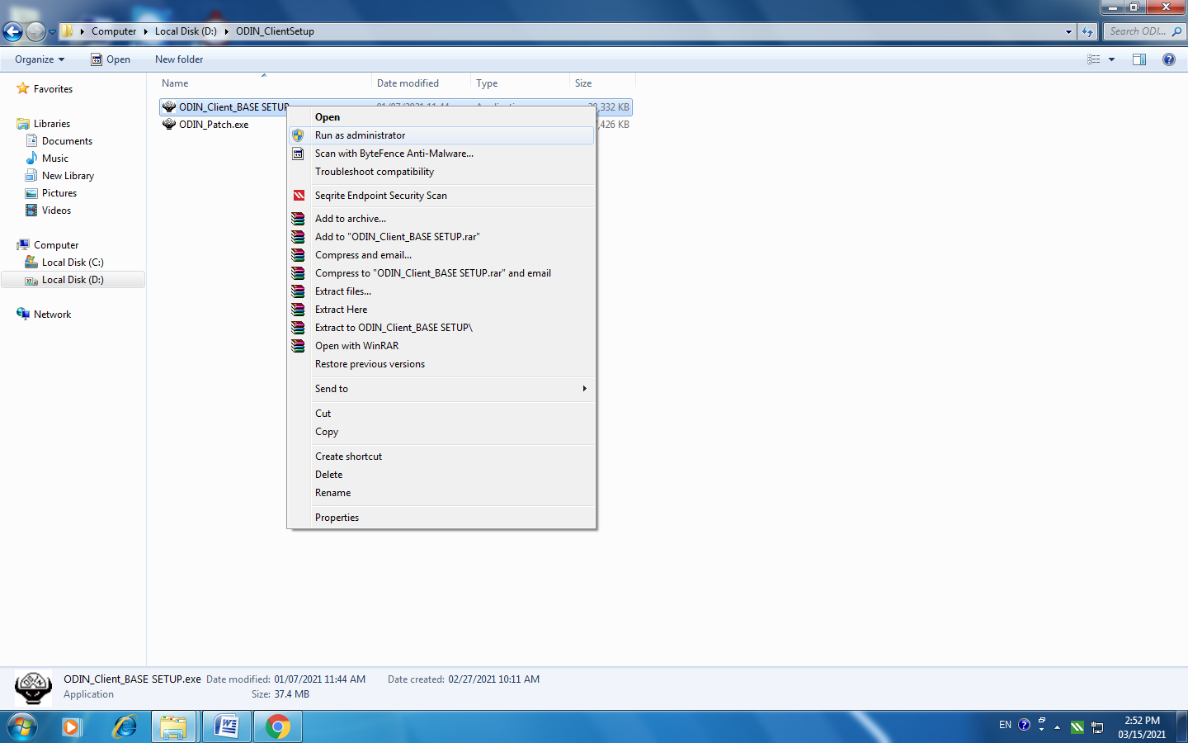

- 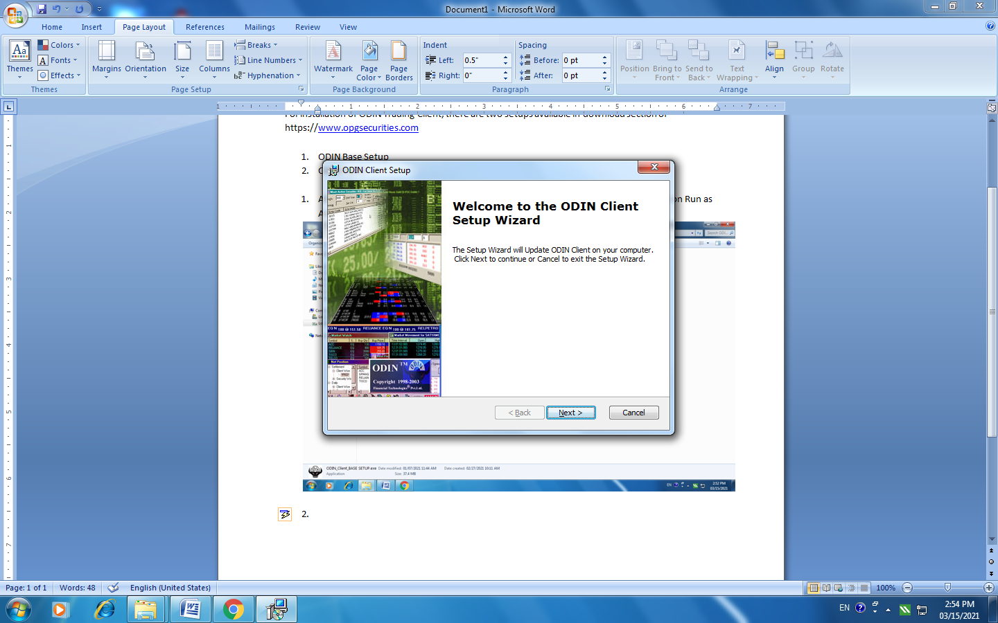

Click Next

- 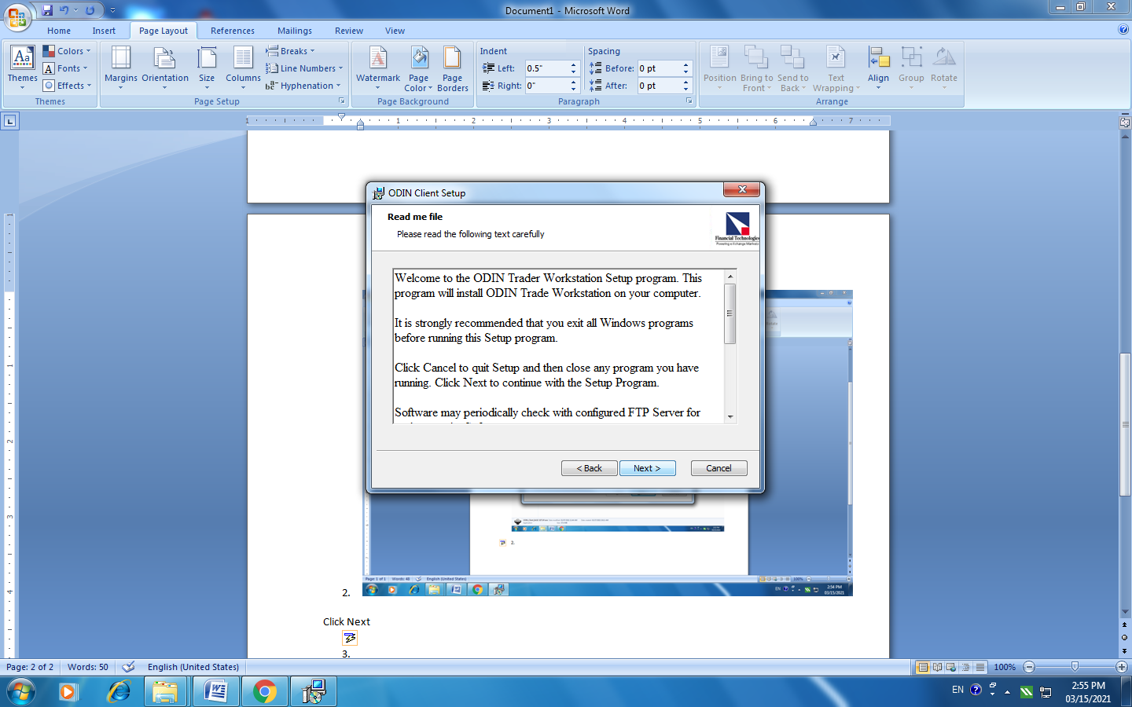

Click Next
- 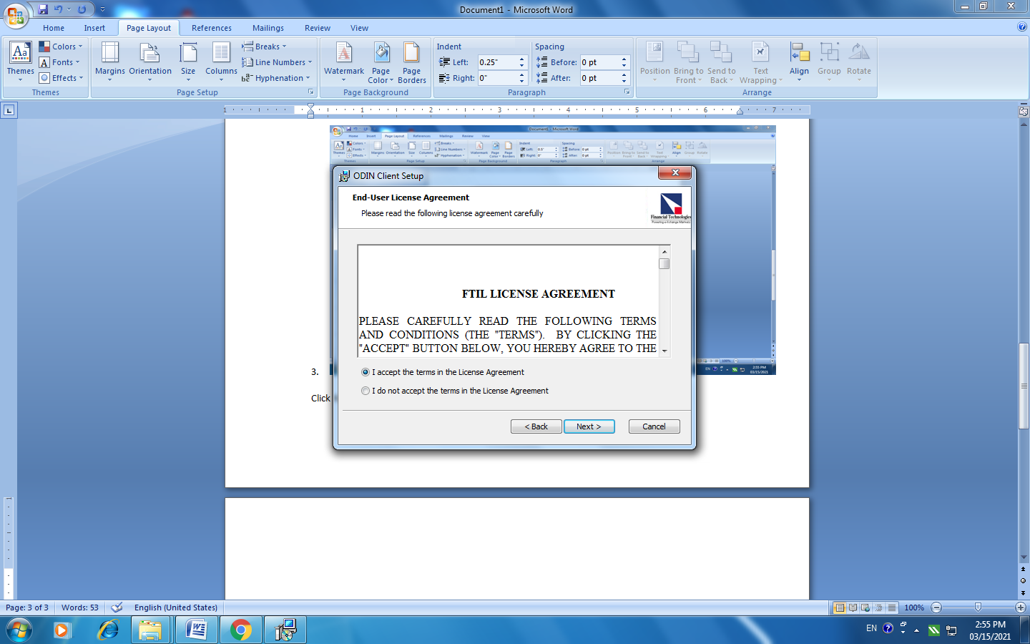

Accept the FTIL License Agreement and Click Next

- 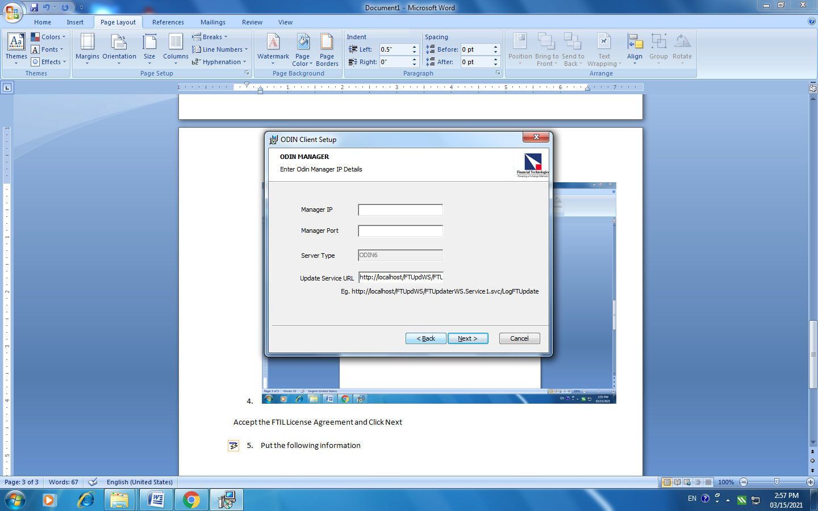
Put the following information:
Manager IP: 182.74.48.62
Manager Port: 777
Click Next

- 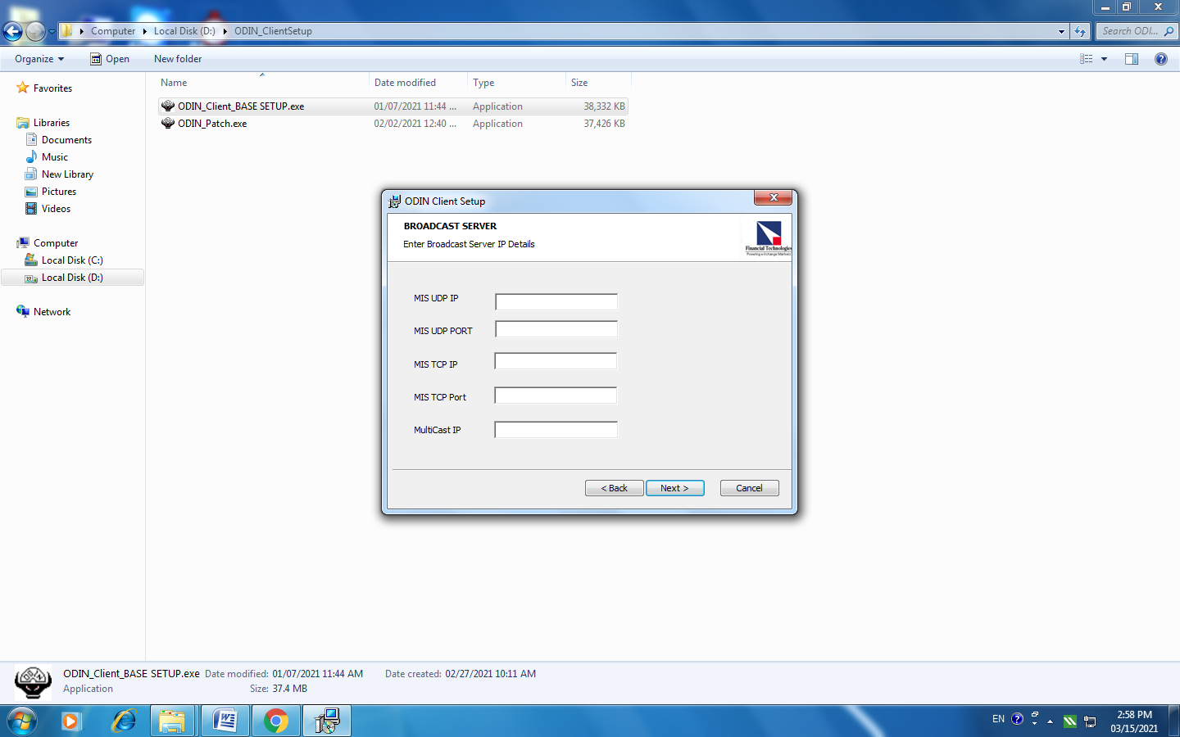

Put the following data in the respective fields:
MIS UDP IP: 182.74.48.62
MIS UDP Port: 8013
MIS TCP Port: 182.74.48.62
MIS TCP Port: 7013
Multicast IP: 239.255.255.255

- 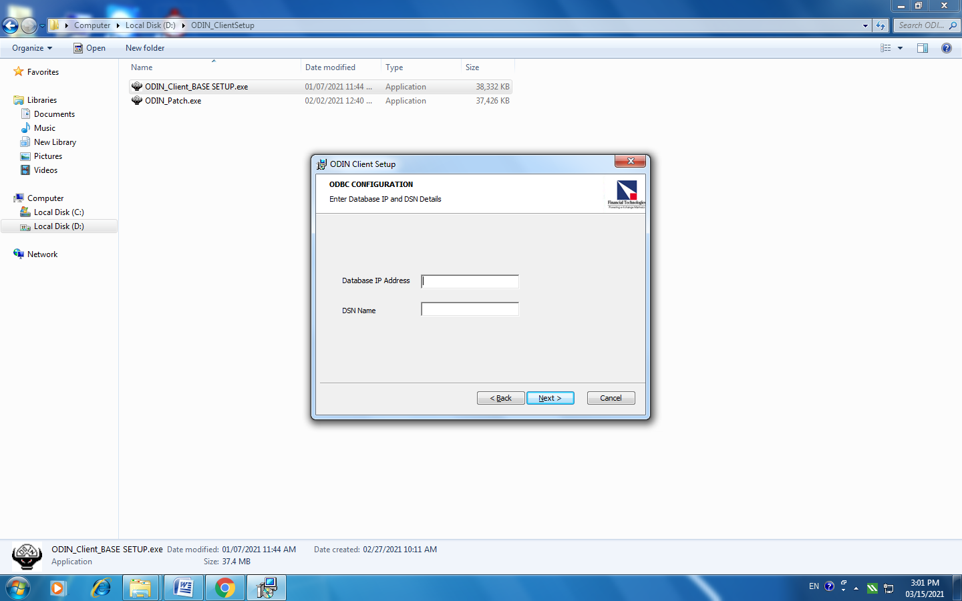

Database IP Address: 182.74.48.62
DSN Name: NSEBSE

- 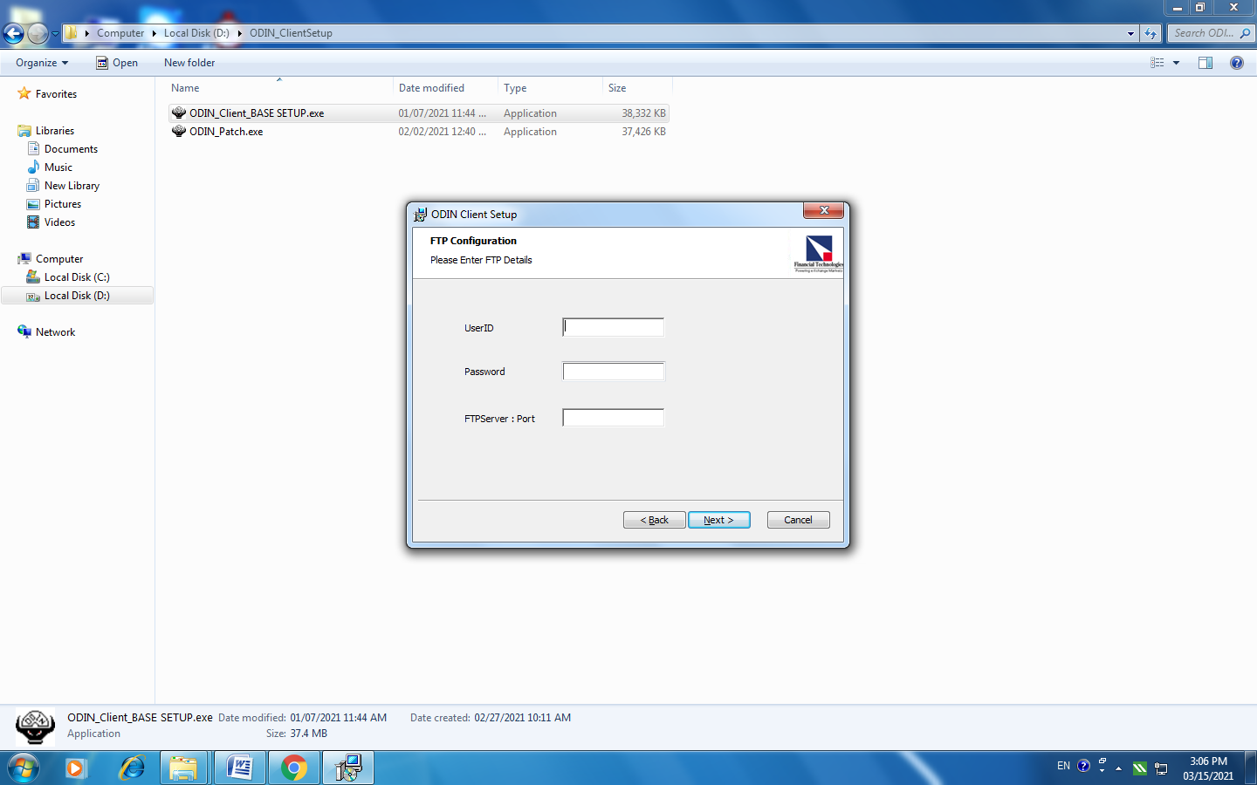

Leave Blank

- 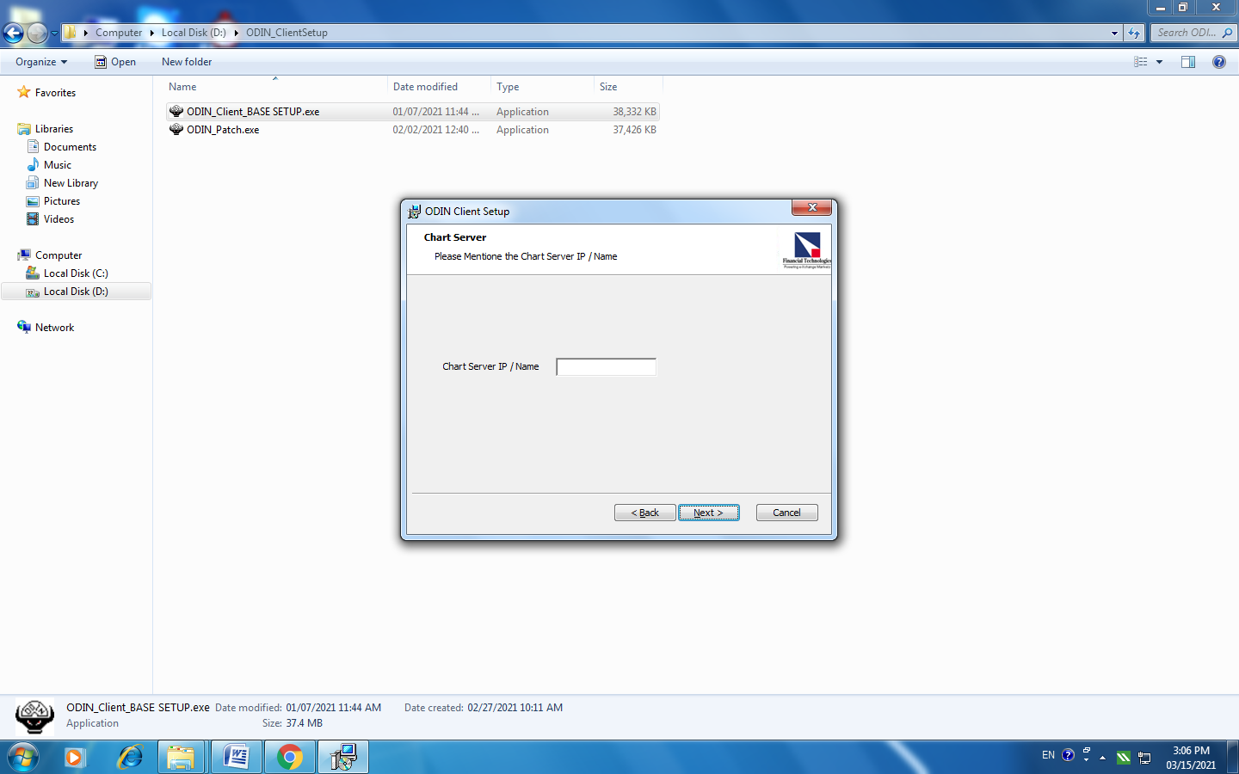

Chart Server IP / Name: 182.74.48.62

- 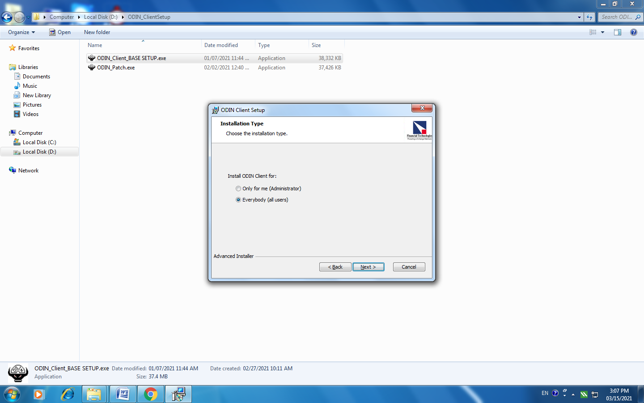

Installation Type: Everybody (All Users)

- 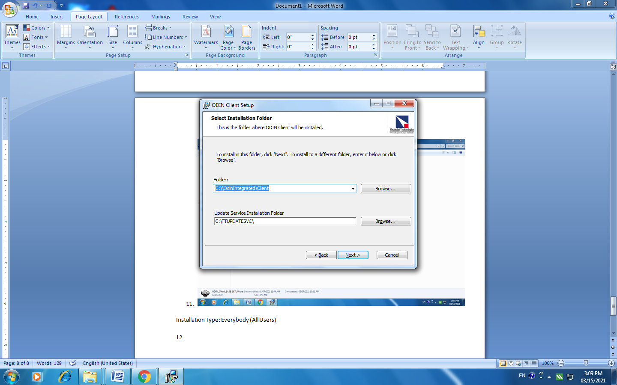

Click Next

- 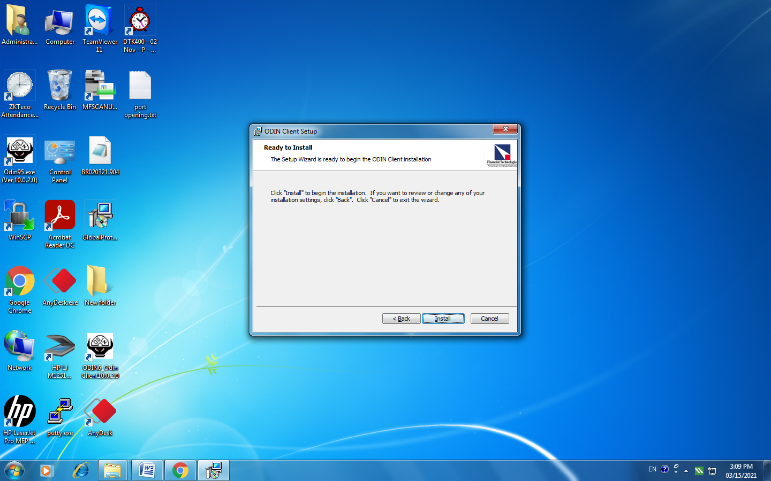

Click on install

14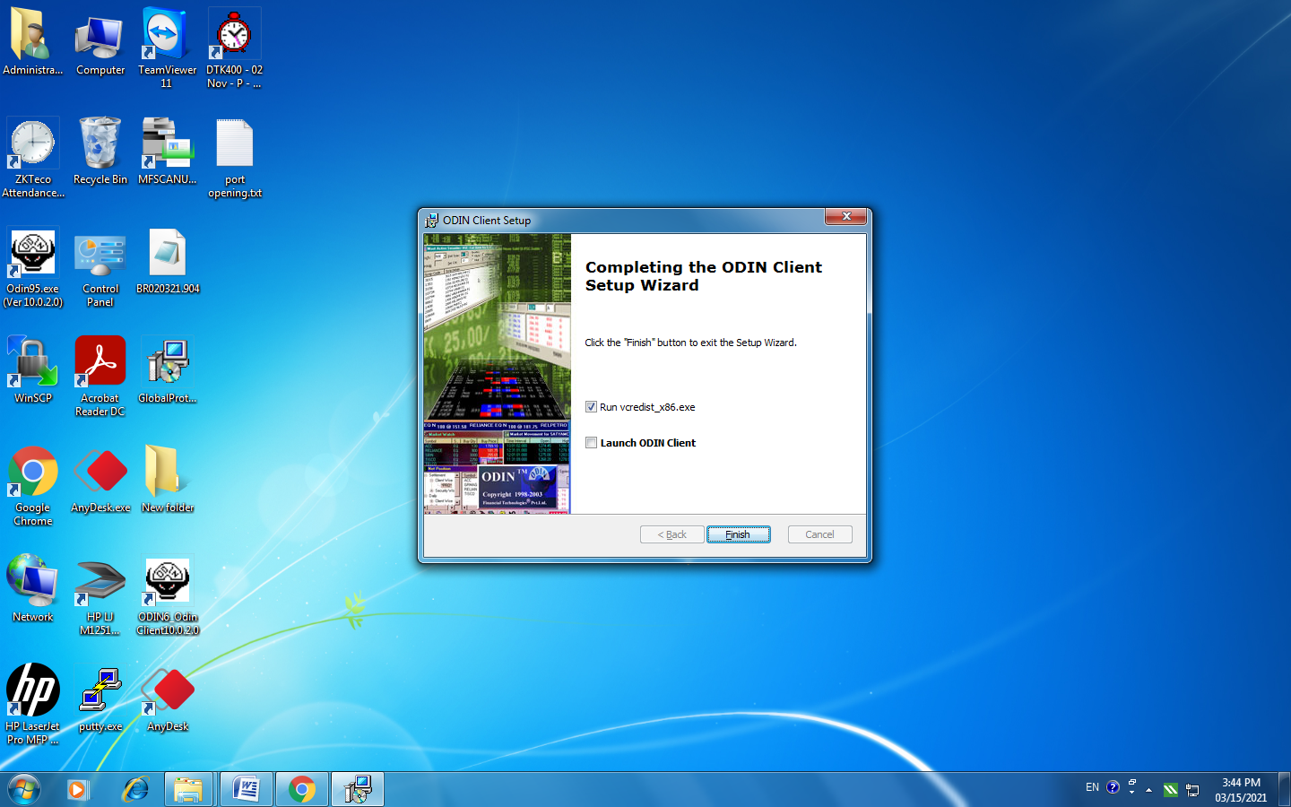

Click Finish.

Right click on the 2nd File and select Run as Administrator
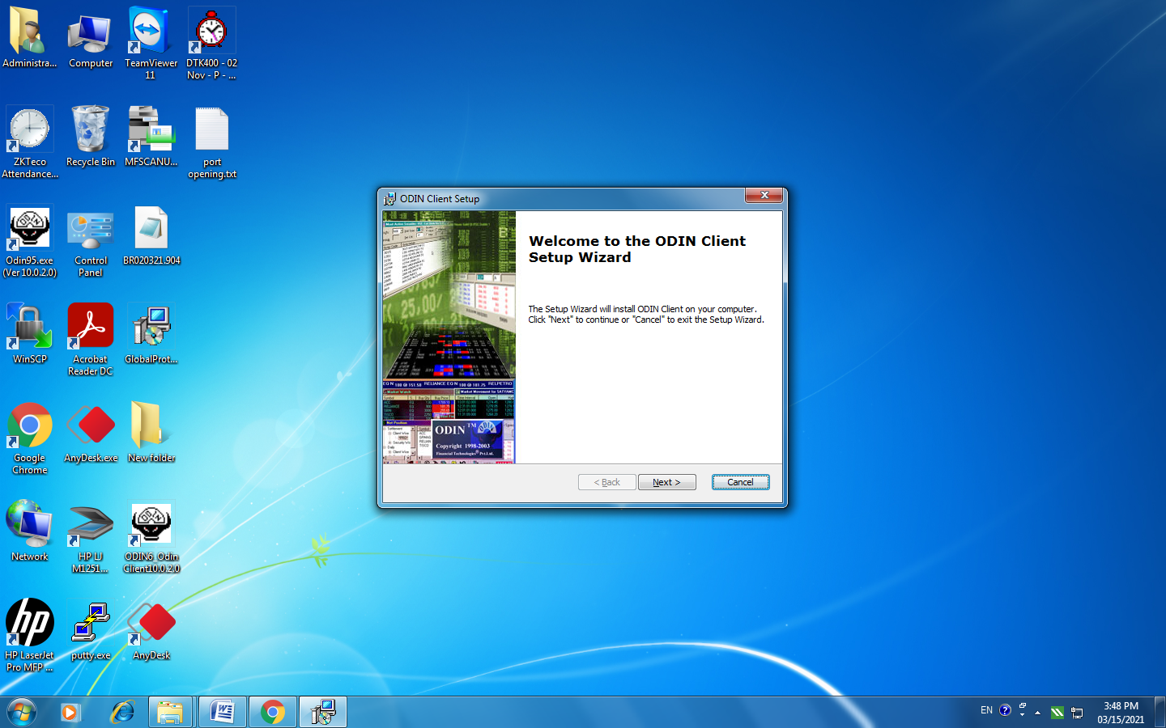

Click Next

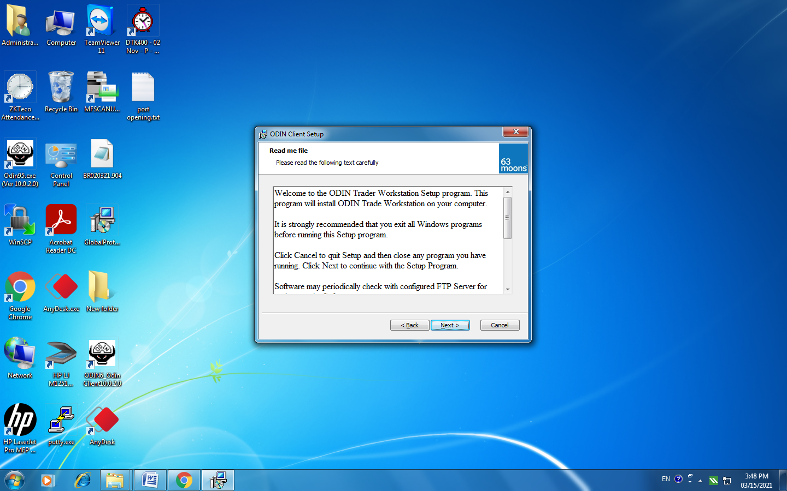

Click Next
Accept the FTIL License Agreement and Click Next

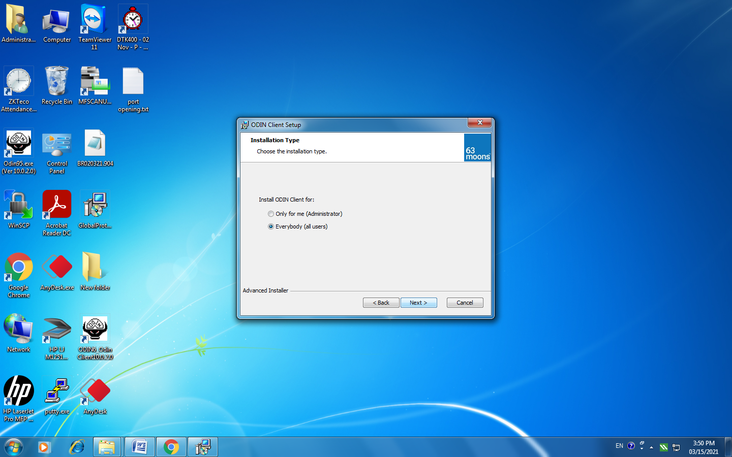

Select Installation Type as Everybody (all users) and Click Next
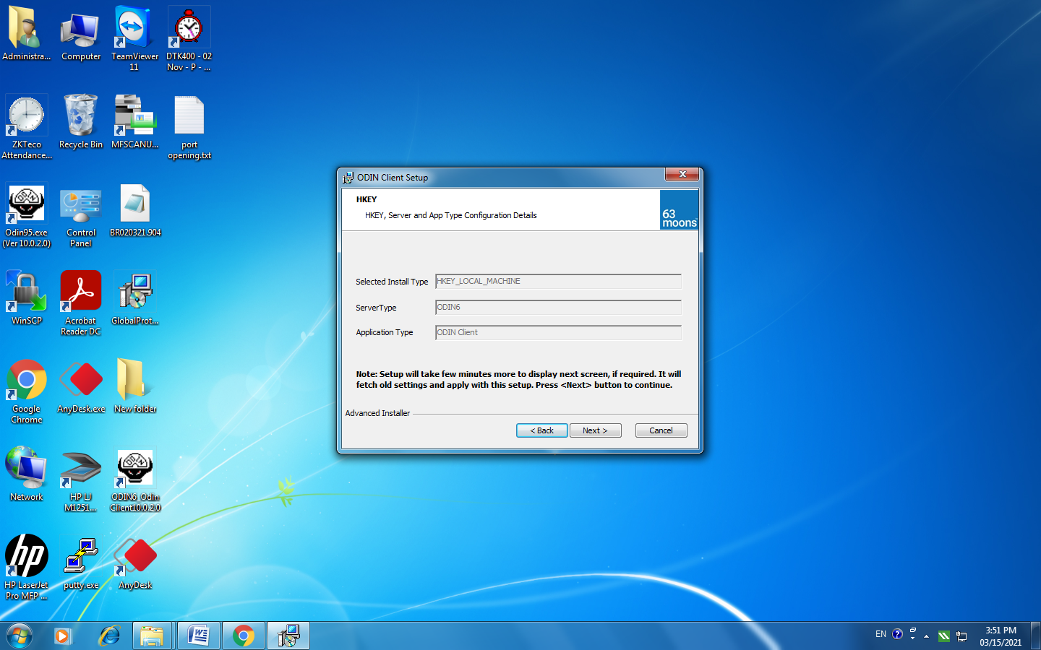
Click Next
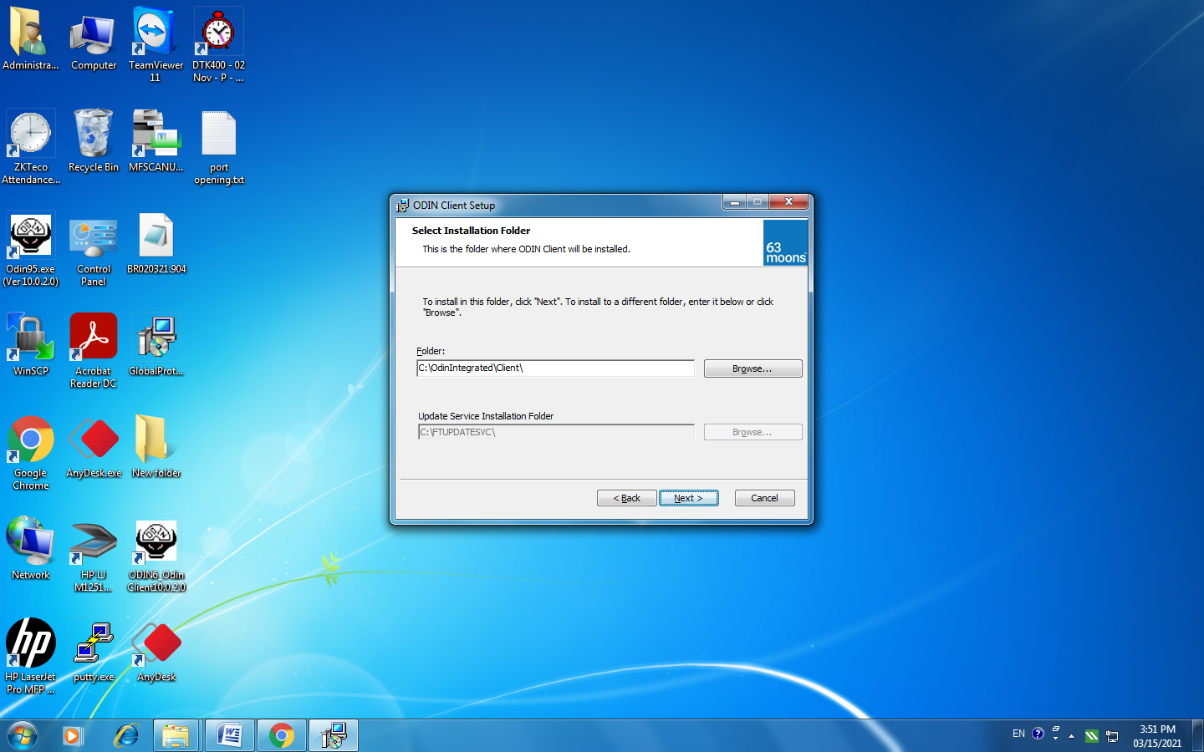

Click Next
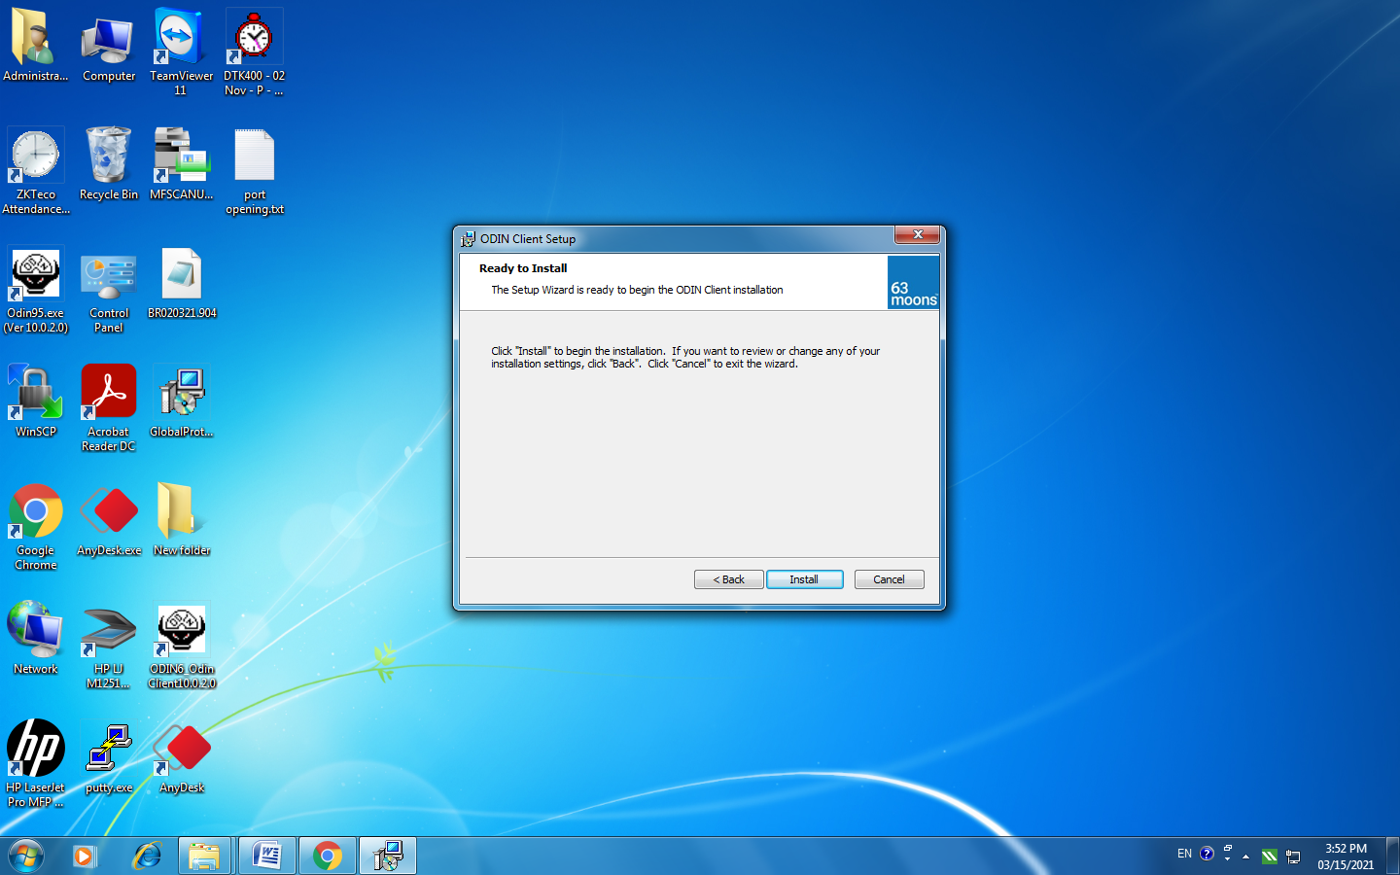
Click Install
Click Finish.

